PR #7 Jessie Royer Wins Race to the Sky 2023

TO: All Media
FROM: Pam Beckstrom, 881-2909, info@racetothesky.org
RE: Race to the Sky Projected Finish of 300
DATE: February 13, 9 p.m.

Jessie Royer is the 2023 Race to the Sky 300 mile race champion again! She crossed the finish line with 11 dogs at 7:40 p.m. under the Hi-Country Snack Foods archway at the finish near Lincoln, Montana.

Royer is from Seeley Lake, Montana. She has been mushing for 31 years and operates the J Team Kennel. She has now won the Race to the Sky seven times. After first winning the 500 mile race when she was 17 years old, she started training to run Iditarod. She has finished may Iditarod (over 1,100 miles) races and has several third place finishes recently. She skipped running Iditarod last year but will be back running it next month with her Alaskan huskies that she raises.

We will have to wait to see who is second. Erik Oline left the White Tail Ranch Checkpoint at 2:44 p.m. with 12 dogs followed by Charmayne Morrison 37 minutes later with 8 dogs.

Clayton Perry is resting at White Tail Ranch Checkpoint for six hours before he can continue to the finish at Hi-Country Snack Foods. He can leave at 11:15 tonight. It will take him about 6 hours to finish once he leaves White Tail Ranch.

The public is welcome to come and cheer the finishers at Hi-Country.

Awards ceremony will be at 1:00 Tuesday at Hi-Country Snack Foods Trading Post for the 300 mile teams. The public is also invited to attend.

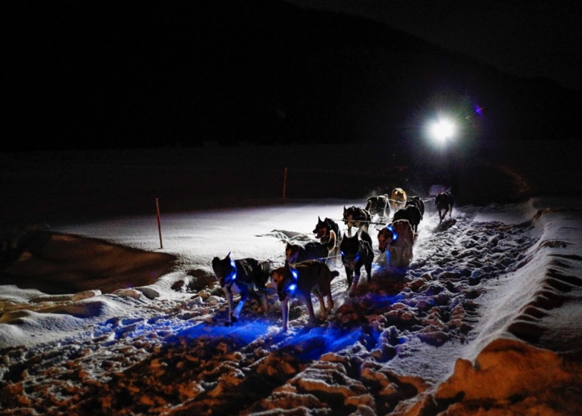Steve Dubois photographer

